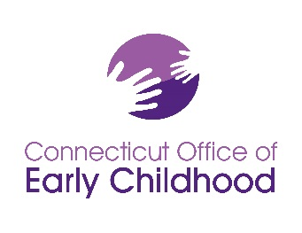
State of Connecticut Office of Early Childhood
Institutional Review Board (IRB)

Instructions: Notice of Termination or Completion of Approved Project
The Office of Early Childhood (OEC) values research that contributes to the field of services and supports, and is committed to protecting the rights of human subjects involved in research. When an approved study is Terminated or Completed, notice must be provided on this form and submitted to the IRB. __________________________________________________________________________________
Scan completed document and submit electronically to oec.irb@ct.gov
__________________________________________________________________________________
Upon receipt, the IRB Chair will complete a preliminary review and may contact the researcher for more information. Incomplete notices will be returned.
Acceptance of the Notice will be provided in writing to the Principal Investigator.
______________________________________________________________________________________
Please be sure that the following are complete and included in your application, as needed:
_____ Notice of Termination or Completion (required)
_____ Adverse Event Report form (required, if applicable)

Required forms may be found at: http://www.ct.gov/oec/cwp/view.asp?a=4546&q=569276

Please detach these instructions before submission.
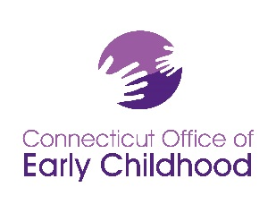
P.I. Name: page ___ of ___ total pages

State of Connecticut Office of Early Childhood
Institutional Review Board (IRB)

Notice of Termination or Completion of Approved Project
For IRB Use only
Date received: ______________________ Original Application #: ______________________

____________________________________ Confirmation Sent: ________________________
IRB Authorized Signature

Date of This Notice:
Project Start Date: Project End date:
Project Title:

_________________________________________________________________________________
Principal Investigator (P.I.) or major advisor, if student project:

Department, university, hospital, or agency affiliation:

Mailing Address:

E-mail: phone:
_________________________________________________________________________________
Co-Investigator(s) or student advisee:

Department, university, hospital, or agency affiliation:

Mailing Address:

E-mail: phone:

P.I. Name: page ___ of ___ total pages

TERMINATION (conclusion prior to approval end date) or COMPLETION (please check one)
Reason:
Project Activities
Research Participants:
# successfully completed their participation
# lost to follow up
# withdrawn
Reasons: # without any adverse event noted
# who experienced adverse events
# other:
total # of participants
Successes:
1.
2.
3.
Challenges:
1.
2.
RESULTS
Presented at : __________________________________________________________
Published in: ___________________________________________________________
Description/Findings:

P.I. Name: page ___ of ___ total pages

Signatures and Assurance of Compliance with Regulations Regarding the
Use of Human Subjects

(initial) I certify that the approved protocol was rigorously followed during the entire study period.
(initial) I certify that the approved method for obtaining informed consent was rigorously followed during the entire study period.
(initial) I certify that there were no adverse events, OR
(initial) I certify that I have reported all adverse events on
date
date
date
(initial) I certify that my research results reported herein are true and accurate to the best of my ability.

Signature: date:
Principal Investigator (or Major Advisor, if student)

Signature: date:
Co-Investigator(s) or student

