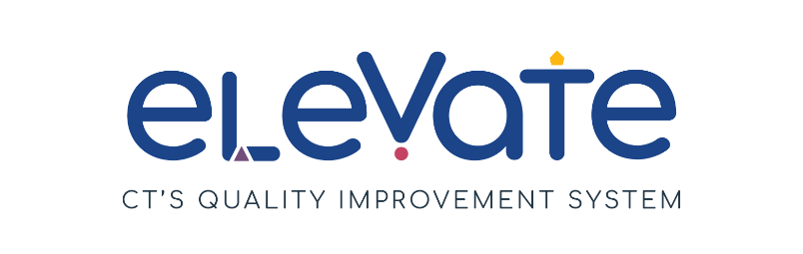

Curriculum Planning Checklist – Centers
Description:
This checklist will help you reflect on the resources your program has to support both planning for children’s learning and development and connections with families.
This checklist was designed for programs beginning to build a strong foundation in planning the materials, activities and teaching that will support children’s learning (curriculum). Programs that have already done a lot of work related to standards, curriculum, and assessment may find it helpful to use the more comprehensive Curriculum Self-Assessment included in Appendix A of Supporting All Children Using the CT ELDS: Building Meaningful Curriculum.

Directions:
Use the checklist below to reflect on your program planning resources and practices. After completing the checklist, reflect on your responses to identify your priorities. Service Navigators can help connect you to OEC resources and guide you to your next step.

Read about curriculum planning at Busy Bees Preschool:
At Busy Bees Preschool, the educators use a project-based curriculum. The educators work hard to include the culture of the children, families, and community in their lesson plans. The educators also offer many opportunities for families be with their children while they learn. The staff wrote a curriculum statement to connect their beliefs about how children learn to the Connecticut Early Learning and Development Standards. This helps them include all the developmental domains in their learning plans. The educators worked as a team to create one lesson planning document for their whole program. This document gives all the educators a space to write down their children’s interests and conversations to plan more project ideas.
Teaching teams meet outside of the classroom weekly to plan learning. Together, they reflect on the photos and lesson planning documents from the week. This helps the adults understand what the children are learning and what they might be curious about. They use their learning to build out future lesson plans.
Overview of Staff Planning and Learning Resources
 | We’ve got this! | We’re a work in progress! | We’re not there yet! | Comments
Our Approach
Our program has a documented curriculum process to guide ongoing intentional planning. (This may involve the use of a purchased curriculum or an emergent/project-based approach.)
We use the CT Early Learning and Development Standards (CT ELDS) to guide my planning for children birth to age five.
Staff have resources to promote planning that align with the curriculum model (see Supporting All Children Using the CT ELDS: A Guide to the Domains and Strands).
Teaching teams have dedicated time for planning.
Our Approach
We have written plans for promoting skills based on the CT ELDS during daily routines, in centers, and during activities.
Our plans reflect the cultures and languages of families and the local community.
Our plans reflect children’s interests.
Our plans for learning experiences and learning centers incorporate skills from multiple learning and development domains.
Teachers observe and reflect on the plans and use this information to guide next steps.
Teachers consistently use the instructional plans.

What Else?
What else does your program do to plan for learning? How do you include families into your lesson planning? How are teachers flexible with their plans based on changing circumstances, child needs, etc.? Does your curriculum process align with your philosophy and mission statement? How are staff made aware of their responsibilities for planning?
You may want to visit CT Shares – Curricula Links to review resources that could be of support in your next steps and planning
https://www.ctshares.org/in-the-classroom/curriculum/curricula-links/

