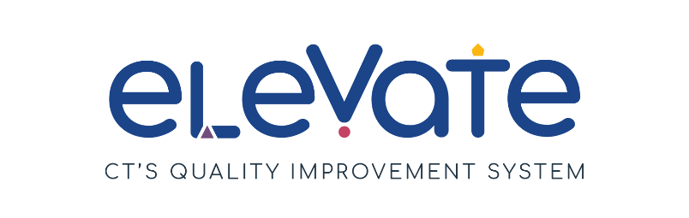

**Create an Elevate Program Plan: Family Child Care Homes**

Developing an Elevate Program Plan is a key step to reaching Member+ status. Your plan outlines how you can bring your program from where it is today to where you want to be.

**Getting Started:**

First, check that you are ready to fill out your Elevate Program Plan:

Have you reflected on areas of strength and areas for growth?

Have you chosen your focus areas?

Do you have 1-3 SMART goals?

**Not yet?**

Refer back to the [Elevate website](https://www.ctoec.org/elevate/create-program-plan/) for full instructions and resources to prepare to fill out your plan.

Need additional help thinking through your program plan? Reach out to your [Service Navigator](https://www.ctoec.org/elevate/service-navigator/) today!

**YES! Congratulations - you are ready!**

**Elevate Program Plan Process Summary:**

* Fully fill out the form below
* Upload to the Registry
* Service Navigators review it
* If needed, they will offer suggestions to get plan approved
* Once a plan is approved by OEC you will enter Member+ Status

**Assessment of your plan:**

OEC will use an assessment tool, called a rubric, to ensure plans meet standards. OEC will approve plans that meet the criteria outlined below. In the event that a plan does not meet those criteria, a Service Navigator will contact you and offer suggestions and support for your plan to help it get approved.

To ensure the plan is approved, providers must:

1. Choose at least one Focus Area.
2. Include at least 1 and up to 3 SMART goals for quality improvement. ​
   1. Each SMART goal should include action steps and challenges, as well as the resources needed to complete the goal.
3. Complete all parts of the Elevate Program Plan template.

Once you have fully completed your plan you are ready to submit it to the Registry. Review this [instructional video](https://youtu.be/YVxYV7v2Wh4) for support submitting your plan.

Once approved, your program will earn Member+ status.

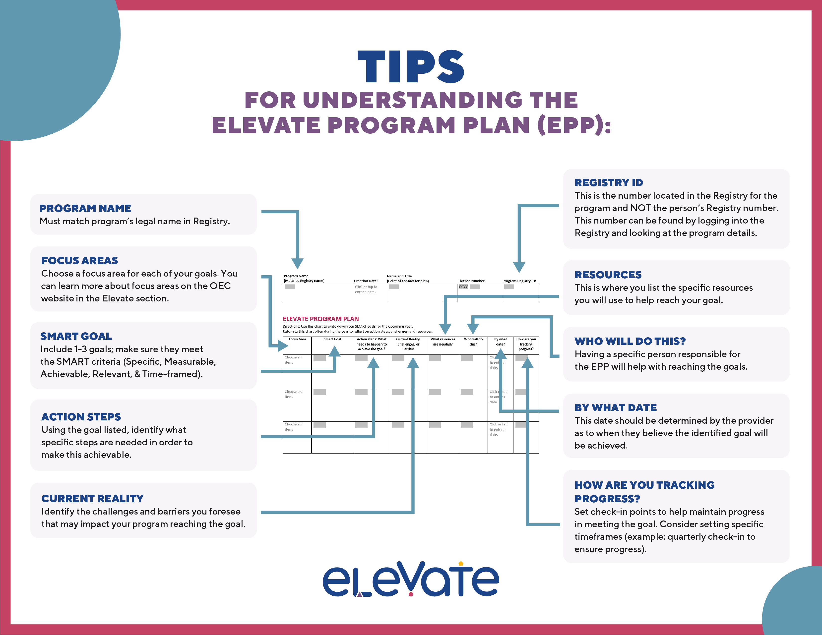

|  |  |  |  |  |
| --- | --- | --- | --- | --- |
|  | Click or tap to enter a date. |  |  |  |

**Program Name**

**(Matches Registry name)**

**Program Registry ID:**

**License Number:**

**Creation Date:**

**Name and Title**

**(Point of contact for plan)**

**ELEVATE PROGRAM PLAN**Directions: Use this chart to write down your SMART goals for the upcoming year.  
Return to this chart often during the year to reflect on action steps, challenges, and resources.

|  |  |  |  |  |  |  |  |
| --- | --- | --- | --- | --- | --- | --- | --- |
| **Focus Area** | **Smart Goal** | **Action steps: What needs to happen to achieve the goal?** | **Current Reality, Challenges, or Barriers** | **What resources are needed?** | **Who will do this?** | **By what date?** | **How are you tracking progress?** |
| Choose an item. |  |  |  |  |  | Click or tap to enter a date. | Ex: at monthly staff meetings |
| Choose an item. |  |  |  |  |  | Click or tap to enter a date. |  |
| Choose an item. |  |  |  |  |  | Click or tap to enter a date. |  |