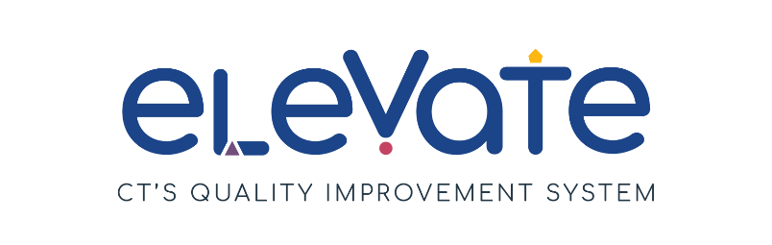

**Create an Elevate Program Plan: Centers and Group Homes**

Developing an Elevate Program Plan is a key step to reaching Member+ status. Your plan outlines how you can bring your program from where it is today to where you want to be.

**Getting Started:**

First, check that you are ready to fill out your Elevate Program Plan:

Have you reflected on areas of strength and areas for growth?

Have you chosen your focus areas?

Do you have 1-3 SMART goals?

Have you thought through a professional development plan for the program and for each educator?

**Not yet?**

Refer back to the [Elevate website](https://www.ctoec.org/elevate/create-program-plan/) for full instructions and resources to prepare to fill out your plan.

Need additional help thinking through your program plan? Reach out to your [Service Navigator](https://www.ctoec.org/elevate/service-navigator/) today!

**YES! Congratulations - you are ready!**

**Elevate Program Plan Process Summary:**

* Fully fill out the form below
* Upload to the Registry
* Service Navigators review it
* If needed, they will offer suggestions to get plan approved
* A screenshot of a video game

  Description automatically generated with medium confidenceOnce a plan is approved by OEC you will enter Member+ Status

**Assessment of your plan:**

OEC will use an assessment tool, called a rubric, to ensure plans meet standards. OEC will approve plans that meet the criteria outlined below. In the event that a plan does not meet those criteria, a Service Navigator will contact you and offer suggestions and support for your plan to help it get approved.

To ensure the plan is approved, providers must:

1. Ensure Program Name in the Elevate Program Plan matches the program's legal name in the Registry.​
2. Choose at least one Focus Area.
3. Include at least 1 and up to 3 SMART goals for quality improvement. ​
   1. Each SMART goal should include action steps and challenges, as well as the resources needed to complete the goal.
4. Complete all parts of the Elevate Program Plan template.
5. Ensure additional requirements are met:​
   1. Include a professional development plan at the program level with at least 1 and up to 3 SMART goals. ​
   2. Include one sample professional development plan for one educator. Programs will keep updated professional development plans for each educator in their program (not including substitute educators or support staff). Programs may use the same SMART goal for more than one educator. ​

Complete the Elevate Program Plan attestation: *By checking this box, I attest that I have one program professional development plan for each educator in my program. (These professional development plans will be available for OEC review upon request.)​*

1. Save your Elevate Program Plan, program professional development plan, and sample educator professional development plan as one file to upload into the Registry.

Once you have fully completed your plan you are ready to submit it to the Registry. Review this [instructional video](https://youtu.be/YVxYV7v2Wh4) for support submitting your plan.

Once approved, your program will earn Member+ status.

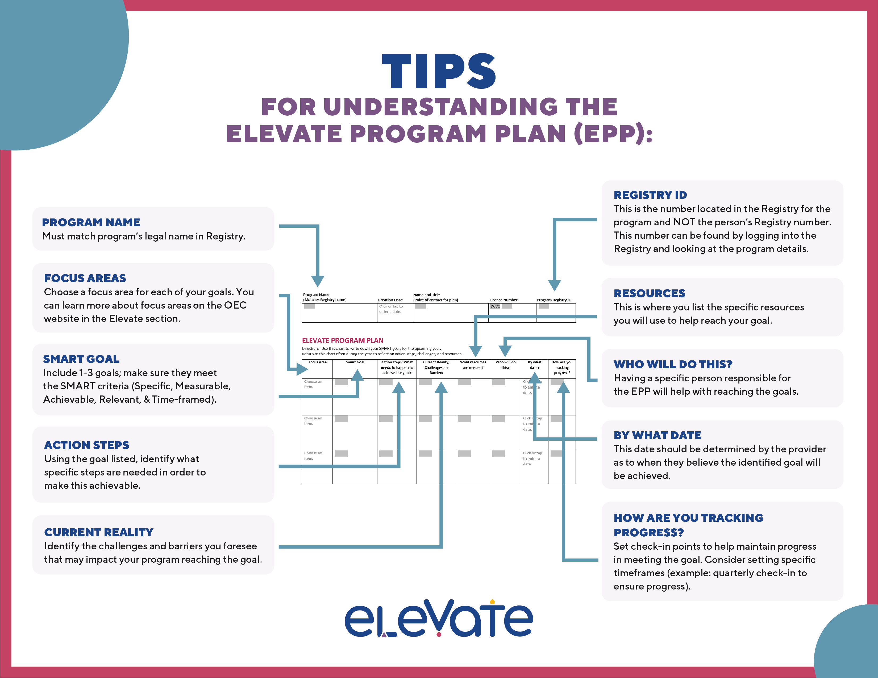

|  |  |  |  |  |
| --- | --- | --- | --- | --- |
| ABC Childcare | 7/18/23 | Howdy Doody, Director | 00000 | 0000 |

**Program Name**

**(Matches Registry name)**

**Program Registry ID:**

**License Number:**

**Creation Date:**

**Name and Title**

**(Point of contact for plan)**

**ELEVATE PROGRAM PLAN**Directions: Use this chart to write down your SMART goals for the upcoming year.  
Return to this chart often during the year to reflect on action steps, challenges, and resources.

|  |  |  |  |  |  |  |  |
| --- | --- | --- | --- | --- | --- | --- | --- |
| **Focus Area** | **Smart Goal** | **Action steps: What needs to happen to achieve the goal?** | **Current Reality, Challenges, or Barriers** | **What resources are needed?** | **Who will do this?** | **By what date?** | **How are you tracking progress?** |
| Build Your Team | **Create a new annual staff survey to learn about employees’ assessment of their work environment and distribute actionable recommendations based on the survey data.** | Identify the best format/template for survey and method of distribution.  Create the survey and solicit feedback from any necessary administrative partners.  Decide on distribution dates/submission timelines.  Distribute survey and evalutate feedback.  Share survey results and gain feedback for actionable recommendations. | Time for the creation of survey and allowing time for staff to complete.  Ensuring confidentiality for staff and obtaining optimal submissions.  Should it be a mandatory vs. optional survey? | Samples of other staff surveys.  Secure mode of submissions of surveys unless electronic. | Director | 10/1/23 | Creating a checklist for the completion of each action step, to be monitored weekly. |
| Choose an item. |  |  |  |  |  | Click or tap to enter a date. |  |
| Choose an item. |  |  |  |  |  | Click or tap to enter a date. |  |

|  |  |
| --- | --- |
| **Program Professional Development Plan**  Directions: Use this chart to write down program-level professional development goals for the upcoming year. Return to this chart often during the year to reflect on action steps and progress. | |
| **Name(s):** Howdy Doody, Director | |
| **Program Name:** ABC Childcare | **Creation Date:**  7/18/23 |
| By checking this box, I attest that I have one program professional development plan for each educator in my program. These professional development plans will be available for OEC review upon request. | |
| **Goal:**  All staff will read at least one article on conscience discipline and one article on play based learning. The articles will be chosen by the Director and distributed. Each staff member will write a reflection on each article read. | |
| **ACTION STEPS** | **PROGRESS REVIEW** |
| 1. Identify one article on each topic for staff to review. | Date: 8/18/23 Completed Steps: |
| 2. Determine how articles will be shared/distributed to staff (via email vs. paper). | Date: 8/18/23 Completed Steps: |
| 3. Distribute the articles to staff and assign a due date for the completion of the reading/reflections. During a staff meeting the team will reflect on the articles. | Date: 9/1/23 Completed Steps: |
| 4. Review previous action steps and determine any changes needed for future implementation. | Date: 10/6/23 Completed Steps: |

|  |  |
| --- | --- |
| **Educator Professional Development Plan**  Use this chart to write down professional development goals for each educator on your staff. Return to this chart often during the year to reflect on your action steps and progress. | |
| **Educator Name:** Mary Smith | **Creation Date:**  7/18/23 |
| **Goal:** Complete a training on the topic of childhood trauma to help me be able to support children in my classroom. | |
| **ACTION STEPS** | **PROGRESS REVIEW** |
| 1. Communicate with Social Service Consultant and/or Director to determine what trainings are available and when. | Date: 12/31/23  Completed Steps: |
| 2. Complete the training and submit certificate of completion to director. | Date: 3/31/24  Completed Steps: |
| 3. Determine ways to take the tools I learn and use them in my classroom. | Date: 4/28/23  Completed Steps: |
| 4. Reflect on the tools that I have used and the impact it has had on the children and classroom. | Date: Six months from implementation  Completed Steps: |

