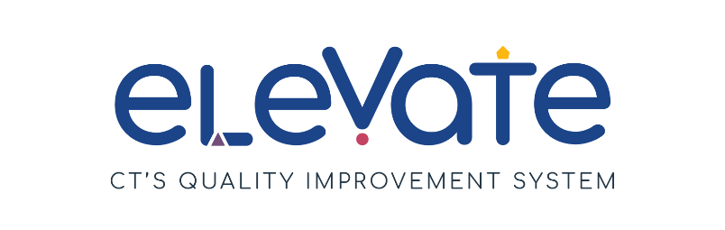

**Create an Elevate Program Plan: Family Child Care Homes**

Developing an Elevate Program Plan is a key step to reaching Member+ status. Your plan outlines how you can bring your program from where it is today to where you want to be.

**Getting Started:**

First, check that you are ready to fill out your Elevate Program Plan:

Have you reflected on areas of strength and areas for growth?

Have you chosen your focus areas?

Do you have 1-3 SMART goals?

**Not yet?**

Refer back to the [Elevate website](https://www.ctoec.org/elevate/create-program-plan/) for full instructions and resources to prepare to fill out your plan.

Need additional help thinking through your program plan? Reach out to your [Service Navigator](https://www.ctoec.org/elevate/service-navigator/) today!

**YES! Congratulations - you are ready!**

**Elevate Program Plan Process Summary:**

* Fully fill out the form below
* Upload to the Registry
* Service Navigators review it
* If needed, they will offer suggestions to get plan approved
* A screenshot of a video game

  Description automatically generated with medium confidenceOnce a plan is approved by OEC you will enter Member+ Status

August 2023

**Assessment of your plan:**

OEC will use an assessment tool, called a rubric, to ensure plans meet standards. OEC will approve plans that meet the criteria outlined below. In the event that a plan does not meet those criteria, a Service Navigator will contact you and offer suggestions and support for your plan to help it get approved.

To ensure the plan is approved, providers must:

1. Choose at least one Focus Area.
2. Include at least 1 and up to 3 SMART goals for quality improvement. ​
   1. Each SMART goal should include action steps and challenges, as well as the resources needed to complete the goal.
3. Complete all parts of the Elevate Program Plan template.

Once you have fully completed your plan you are ready to submit it to the Registry. Review this [instructional video](https://youtu.be/YVxYV7v2Wh4) for support submitting your plan.

Once approved, your program will earn Member+ status.

August 2023

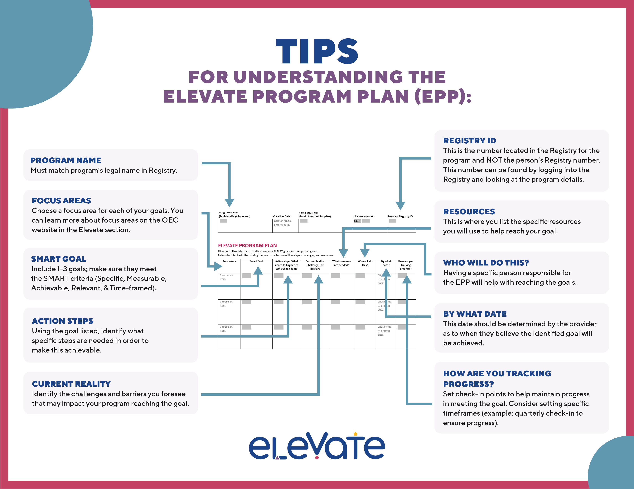

August 2023

|  |  |  |  |  |
| --- | --- | --- | --- | --- |
| Susie Snowflake | 7/18/23 | Susie Snowflake | DCFH 00000 | 12345 |

**Program Name**

**(Matches Registry name)**

**Program Registry ID:**

**License Number:**

**Creation Date:**

**Name and Title**

**(Point of contact for plan)**

**ELEVATE PROGRAM PLAN**Directions: Use this chart to write down your SMART goals for the upcoming year.  
Return to this chart often during the year to reflect on action steps, challenges, and resources.

August 2023

|  |  |  |  |  |  |  |  |
| --- | --- | --- | --- | --- | --- | --- | --- |
| **Focus Area** | **Smart Goal** | **Action steps: What needs to happen to achieve the goal?** | **Current Reality, Challenges, or Barriers** | **What resources are needed?** | **Who will do this?** | **By what date?** | **How are you tracking progress?** |
| Build Your Team | **Work with OEC licensing, to get my 19 year old daughter approved to work as my FCC assistant** | Request/download the OEC assistant application  Review application with OEC Help Desk to answer any questions.  Complete background check for daughter.  Complete the required Adult Medical Statement.  Help daughter to obtain the 3 references required.  Complete and sbmit completed application/fee to OEC. | The biggest barrier is time for daughter to complete the required items and the timeline involved in awaiting OEC approval once the application is submitted.  Obtaining any money needed or required checks and application fees. | Access to fingerprinting that is local.  Ensuring daughters physical can be completed in a timely manner.  Identifying adequate resources who are able to offer a letter of reference.  Identifying/connecting with the OEC person responsible for application submissions/review. | Myself and my daughter. | 12/31/23 | Create a checklist for the completion of each action step to be monitored bi-weekly until goal is achieved. |
| Choose an item. |  |  |  |  |  | Click or tap to enter a date. |  |
| Choose an item. |  |  |  |  |  | Click or tap to enter a date. |  |

August 2023