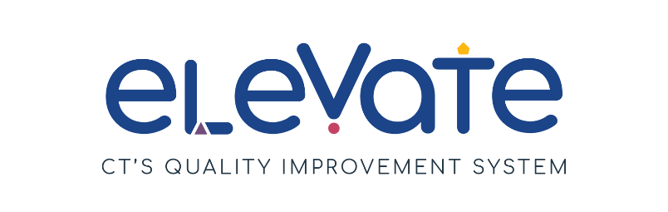

**Sample Developing Educator PD Plan**

Use this **Educator Professional Development Plan** as a tool to guide a conversation between a supervisor and an educator to plan the educator’s professional goals and next steps.

|  |  |
| --- | --- |
| **Educator Professional Development Plan** | |
| Program Name: Crafty Creations Child Care | Plan Creation Date: 7/13/2024 |
| Educator: Merida Bear | |
| **SMART Goal:**  By 9/1/2025 I will complete all necessary parts of the CDA process to complete my CDA in preschool. | |
| **ACTION STEPS** | **PROGRESS REVIEW** |
| 1. Register for classes through CT State. | Completed Steps: |
| 1. Complete paperwork for OEC Scholarship. | Completed Steps: |
| 1. Purchase necessary books etc. And complete courses. | Completed Steps: |
| 1. Complete CDA portfolio and apply for CDA with a visit from a PD specialist from the CDA council. | Completed Steps: |
| 1. Use my skills in my daily interactions with children and families. | Completed Steps: |