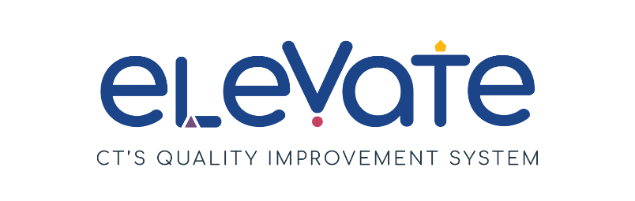
Communicating with Families Checklist
Use this checklist to evaluate family communication in your program. For each item, place a check in the column that applies. Use “We’ve got this!” for items that are working well. Use “This is a work in progress” for your growth areas. After you complete the checklist, think about how your responses might point you to a place to start your quality improvement work.

 | We’ve got this! | This is a work in progress
We ask families to share their child’s needs, strengths, and interests
We help families access special education services as appropriate
We regularly discuss children’s developmental milestones, positive behaviors, and accomplishments with their family
We respect the confidentiality of all family and child information
We communicate promptly with families about learning or behavioral concerns
We have a space in our common area to share information with families, including the program’s mission and vision statements
We provide a Family Handbook to families to explain our policies and procedures
We host at least one open house or orientation for all families each year
We communicate with families using multiple methods such as phone calls, e-mails, newsletters, school website, social media
Families can communicate with us using multiple methods such as phone calls, e-mails, newsletters, school website, social media
We provide written and verbal communication in families’ home language. We arrange translation services when necessary
Our Family Handbook includes policies to address disagreements between the family and the program

