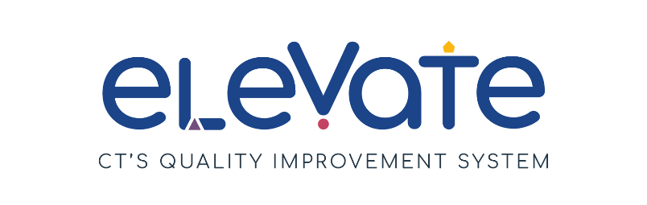

**Developing Program PD Plan**

The **Program Professional Development Plan** outlines common learning goals for your staff as a program.

|  |  |
| --- | --- |
| **Program Professional Development Plan** | |
| Program Name: | Plan Creation Date: |
| Your Name: | |
| **SMART Goal:** | |
| **ACTION STEPS:**  1.  2.  3.  4.  5. | |