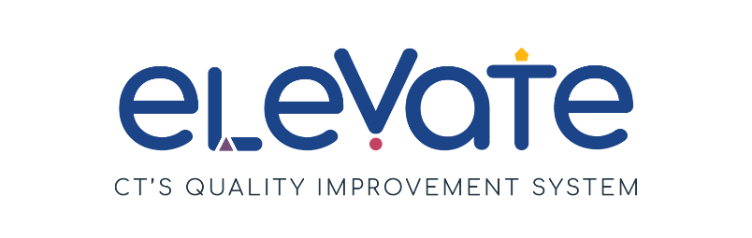
Playful Learning Checklist
Children learn best through play. Use this checklist to think about how children learn through play in your program. For each item, place a check in the column that applies. Use “We’ve got this!” for items that are working well. Use “This is a work in progress” for your growth areas. After you complete the checklist, think about how your responses might point you to a place to start your quality improvement work.

 | We’ve got this! | This is a work in progress
Types of Play
Children have opportunities for free play.
In free play, adults only offer support if needed. Free play can be with materials or ideas, alone or with others.
Children have opportunities for sensorimotor play.
Sensorimotor play is any physical activity that engages multiple senses.
Children have opportunities for constructive play.
Children can make creations from objects and materials like blocks.
Children have opportunities for dramatic play.
In dramatic play, children take on pretend roles.
Children have opportunities for symbolic play.
In symbolic play, children use objects such as blocks or cardboard boxes to substitute for real objects. Symbolic play combines constructive and dramatic play.
Children have opportunities for gross-motor play.
Gross-motor play requires children to use their large muscles.

