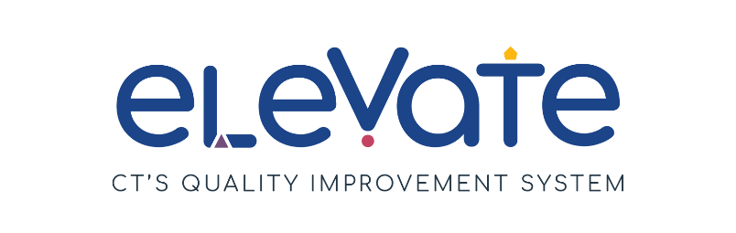

**Developing Renewal Program PD Plan**

The **Developing Program Professional Development Plan** outlines common learning goals for your staff as a program. Reflect on last year’s goal(s) and determine next steps for your program. You can build on your goals from last year, continue to work on unmet goals, or start a new path for this year.

|  |  |
| --- | --- |
| **Program Professional Development Plan** | |
| Program Name: | Plan Creation Date: |
| Your Name: | |
| **Reflection on last year's Goal 1:** *Were there challenges you did not expect? What will you do differently next time? Which OEC resources did you find useful? If you achieved your goals, what got you there?* | |
|  | |
| Were you able to complete your goal? | p Yes  p No |
| Will you continue work on this goal in the upcoming year?   * *Some goals take time! If you are keeping your goal for the upcoming year, please revise your Action Steps based on your current challenges, realities and barriers.* | p Yes  p No |
| **SMART Goal for the upcoming year:** | |
| **ACTION STEPS:** | |

|  |  |
| --- | --- |
| **Program Professional Development Plan** | |
| Program Name: | Plan Creation Date: |
| Your Name: | |
| **Reflection on last year's Goal 2:** *Were there challenges you did not expect? What will you do differently next time? Which OEC resources did you find useful? If you achieved your goals, what got you there?* | |
|  | |
| Were you able to complete your goal? | p Yes  p No |
| Will you continue work on this goal in the upcoming year?   * *Some goals take time! If you are keeping your goal for the upcoming year, please revise your Action Steps based on your current challenges, realities and barriers.* | p Yes  p No |
| **SMART Goal for the upcoming year:** | |
| **ACTION STEPS:** | |

|  |  |
| --- | --- |
| **Program Professional Development Plan** | |
| Program Name: | Plan Creation Date: |
| Your Name: | |
| **Reflection on last year's Goal 3:** *Were there challenges you did not expect? What will you do differently next time? Which OEC resources did you find useful? If you achieved your goals, what got you there?* | |
|  | |
| Were you able to complete your goal? | p Yes  p No |
| Will you continue work on this goal in the upcoming year?   * *Some goals take time! If you are keeping your goal for the upcoming year, please revise your Action Steps based on your current challenges, realities and barriers.* | p Yes  p No |
| **SMART Goal for the upcoming year:** | |
| **ACTION STEPS:** | |