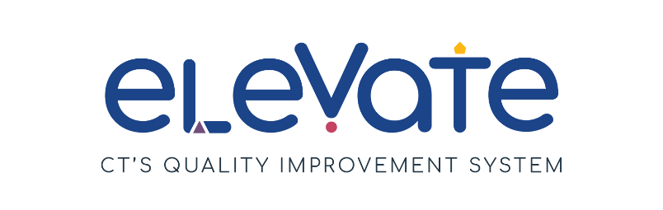

**Developing Renewal Program Plan**

The **Developing Renewal Program Plan** is for you to plan your continuous improvement process. You can use this form as a draft plan. You can also use it throughout the year as you work toward your goals.

**Getting Started**

All Program Plans include SMART Goals and plans to make them happen.

* Do you need to learn more about SMART Goals? Check out our resources [here](https://www.ctoec.org/elevate/create-program-plan/center-group-program-plan/).
* Don't know where to start? Read more about [Elevate Focus Areas](https://www.ctoec.org/elevate/focus-areas/).
* Want to learn more about Elevate? Learn more [here](https://www.ctoec.org/elevate/).

**Reflections**

Reflection is an important part of the continuous quality improvement process. Return to your Plan often and consider:

Areas of strength

Areas for growth

Feedback from your staff

Feedback from the families you serve

**Next Steps**

You can use your Developing Plan as a draft for the Elevate Renewal Plan on the [OEC Provider Portal](https://oec.service.ct.gov/provider360/s/mydashboard). Renewal Plans are submitted annually on the OEC 360 Provider Portal to maintain the Member+ Elevate Level of Engagement.

Need additional help thinking through your Renewal? Reach out to your [Service Navigator](https://www.ctoec.org/elevate/service-navigator/) today!

**Developing Renewal Program Plan**

Use this form to plan your SMART goals for the year ahead. Return to it often to reflect on action steps, challenges, and resources.

|  |  |
| --- | --- |
| **Reflection on last year's Goal 1:** *Were there challenges you did not expect? What will you do differently next time? Which OEC resources did you find useful? If you achieved your goals, what got you there?* | |
|  | |
| Were you able to complete your goal? | p Yes  p No |
| Will you continue work on this goal in the upcoming year?   * *Some goals take time! If you are keeping your goal for the upcoming year, please revise your Action Steps based on your current challenges, realities and barriers.* | p Yes  p No |

|  |  |
| --- | --- |
| **SMART Goal for the upcoming year:** | |
| Focus Area   * *Choose one* | p Build your Team  p Connect with Families  p Enhance your Environment  p Find Resources for Children and Families  p Manage your Business  p Support Child Development |
| Action steps: What needs to happen to achieve the goal?   * *Use bullet points for each step. Avoid long sentences and paragraphs.* |  |
| Current Reality, Challenges, or Barriers   * *Choose all that apply* | p Time needed away from caring for children  p Money needed to complete goal  p Staffing shortage  p Low enrollment  p Other reason: |
| What resources are needed?   * *List the specific tools and resources you will use to reach your goal.* |  |
| Who will do this?   * *Having a specific person in the program responsible for the EPP, will help in reaching the goal.* |  |
| By what date?   * *Choose a date for when you believe the identified goal will be achieved.* |  |
| How are you tracking progress?   * *Set check-in points to help maintain progress.* |  |

|  |  |
| --- | --- |
| **Reflection on last year's Goal 2:** *Were there challenges you did not expect? What will you do differently next time? Which OEC resources did you find useful? If you achieved your goals, what got you there?* | |
|  | |
| Were you able to complete your goal? | p Yes  p No |
| Will you continue work on this goal in the upcoming year?   * *Some goals take time! If you are keeping your goal for the upcoming year, please revise your Action Steps based on your current challenges, realities and barriers.* | p Yes  p No |

|  |  |
| --- | --- |
| **SMART Goal for the upcoming year:** | |
| Focus Area   * *Choose one* | p Build your Team  p Connect with Families  p Enhance your Environment  p Find Resources for Children and Families  p Manage your Business  p Support Child Development |
| Action steps: What needs to happen to achieve the goal?   * *Use bullet points for each step. Avoid long sentences and paragraphs.* |  |
| Current Reality, Challenges, or Barriers   * *Choose all that apply* | p Time needed away from caring for children  p Money needed to complete goal  p Staffing shortage  p Low enrollment  p Other reason: |
| What resources are needed?   * *List the specific tools and resources you will use to reach your goal.* |  |
| Who will do this?   * *Having a specific person in the program responsible for the EPP, will help in reaching the goal.* |  |
| By what date?   * *Choose a date for when you believe the identified goal will be achieved.* |  |
| How are you tracking progress?   * *Set check-in points to help maintain progress.* |  |

|  |  |
| --- | --- |
| **Reflection on last year's Goal 3:** *Were there challenges you did not expect? What will you do differently next time? Which OEC resources did you find useful? If you achieved your goals, what got you there?* | |
|  | |
| Were you able to complete your goal? | p Yes  p No |
| Will you continue work on this goal in the upcoming year?   * *Some goals take time! If you are keeping your goal for the upcoming year, please revise your Action Steps based on your current challenges, realities and barriers.* | p Yes  p No |

|  |  |
| --- | --- |
| **SMART Goal for the upcoming year:** | |
| Focus Area   * *Choose one* | p Build your Team  p Connect with Families  p Enhance your Environment  p Find Resources for Children and Families  p Manage your Business  p Support Child Development |
| Action steps: What needs to happen to achieve the goal?   * *Use bullet points for each step. Avoid long sentences and paragraphs.* |  |
| Current Reality, Challenges, or Barriers   * *Choose all that apply* | p Time needed away from caring for children  p Money needed to complete goal  p Staffing shortage  p Low enrollment  p Other reason: |
| What resources are needed?   * *List the specific tools and resources you will use to reach your goal.* |  |
| Who will do this?   * *Having a specific person in the program responsible for the EPP, will help in reaching the goal.* |  |
| By what date?   * *Choose a date for when you believe the identified goal will be achieved.* |  |
| How are you tracking progress?   * *Set check-in points to help maintain progress.* |  |