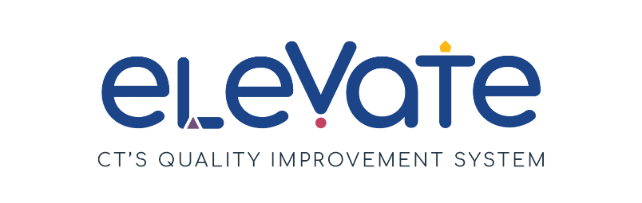
Environmental Checklist
Use this checklist to evaluate your programs environment. For each item, place a check in the column that applies. Use “We’ve got this!” for items that are working well. Use “This is a work in progress” for your growth areas. After you complete the checklist, think about how your responses might point you to a place to start your quality improvement work.

 | We’ve got this! | This is a work in progress
Our Learning Spaces
Entry is clean and inviting
Learning spaces are well lit
Learning spaces are free from clutter
Noise levels support learning
Children have choices of age-appropriate toys connected to learning topics
Our learning equipment and supplies are well kept, including:
- Buckets, baskets and containers are clean with safe edges
- Furniture is safe and clean.
- Puzzles have all pieces
- Books have all pages
- Toys have all pieces needed for full use etc.
We have safe outdoor space to support age-appropriate gross motor play
Children can run, climb, pedal, jump, crawl, explore, etc.
We regularly use outdoor space to support learning experiences
We have a quiet space to meet with families
There is a place in our building for educators and/or staff to take a break

