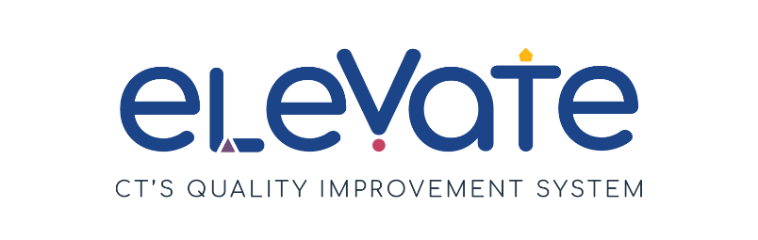
Planning Learning Experiences Checklist
Use this checklist to think about how you plan learning experiences in your program. For each item, place a check in the column that applies. Use “We’ve got this!” for items that are working well. Use “This is a work in progress” for your growth areas. After you complete the checklist, think about how your responses might point you to a place to start your quality improvement work.

 | We’ve got this! | This is a work in progress
Our Learning Experience Plans
We have written plans for learning experiences
Our plans include daily routines, educator-led learning experiences, and centers for play-based exploration
Our plans are aligned with the Connecticut Early Learning & Development Standards (CT ELDS)
Our plans reflect children’s interests
Our plans reflect the cultures and languages of our families
Our plans incorporate skills from multiple learning and development domains
We include families in children’s learning experiences
How We Create Learning Plans
Educators consistently use their learning experience plans for the cycle of intentional teaching
The cycle of intentional teaching includes observing, assessing, planning and implementing
Educators have dedicated time to plan learning experiences
Educators regularly reflect on learning experience plans over time
Educators adjust their plans based on children’s needs

