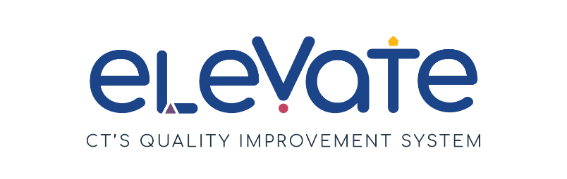
Thinking About Accreditation?
Accredited programs follow national program standards for high quality. Elevate recognizes program standards from the National Association for the Education of Young Children (NAEYC), the National Association for Family Child Care (NAFCC), and Head Start.

This checklist was created to help you start to think about pursuing national program standards. Most programs do not have all these pieces in place when they begin to consider accreditation. That’s OK! Use this checklist to evaluate your program’s strengths and growth areas to prepare for accreditation. This is where growth begins.

We’ve split this checklist into items for all programs and items for centers only. For each item, place a check in the column that applies. Use “We’ve got this!” for items that are working well. Use “This is a work in progress” for your growth areas. After you complete the checklist, think about how your responses might point you to the next steps in your quality improvement work.

ALL PROGRAMS
 | We’ve got this! | We’re working on this!
In our program, we have a staff handbook and a family handbook.
We write lesson plans to address these areas of learning and development: cognition, social and emotional development, physical development, language and literacy, creative arts, math, science, and social studies.
We have a written assessment plan that addresses developmental screening and assessment.
We use assessment and screening data to evaluate children’s learning, plan instruction, and for referrals.
We gather input from families to support ongoing program improvement.
Our program is in good standing with OEC licensing standards or has corrected any non-compliance issues.

CENTERS AND GROUP HOMES
 | We’ve got this! | We’re working on this!
We have regularly scheduled staff meetings.
We gather input from program staff to inform ongoing program improvement.
Staff participate in planning their professional growth.
Our educators are on a path
to improve their higher
education credentials.
Our program administrator has experience managing change in early childhood programs.

